EE239AS – PROJECT 1 REPORT

NETWORK BACKUP DATASET

1. When we plot actual copy sizes of all the files for a given workflow over time, we get a pattern. In each period, majority of the time, the file copy size is similar and then it peaks for a small time intervel before the next cycle begins.

Figures below show the plots of copy sizes of all the files plotted against the time (we have added the copy sizes for all the files at the particular time) for Workflow -1.

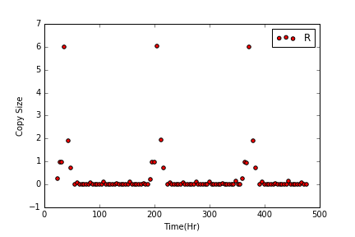
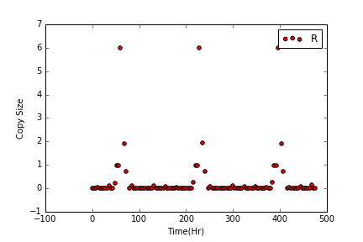
Figure for Workflow-1 days 1 to 20. Figure for Workflow-1 days 21 to 40
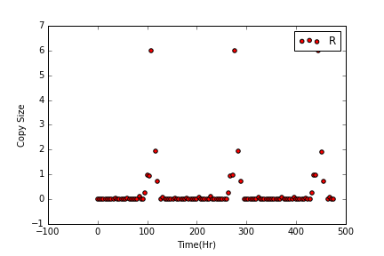
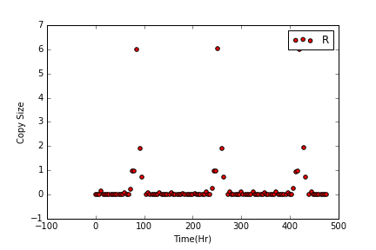

Figure for Workflow-1 days 41 to 60 Figure for Workflow-1 days 61 to 80

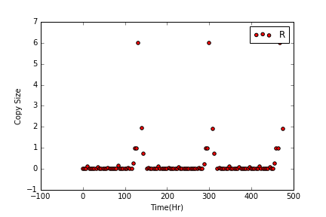

Figure for Workflow-1 days 81 to 100

Similar plots are given below for other workflows
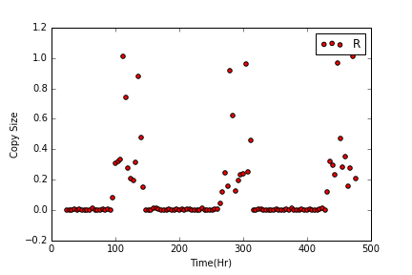
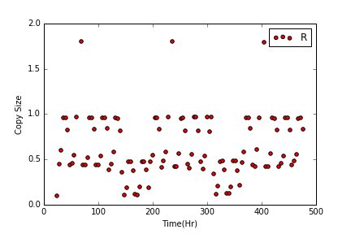

Figure for Workflow-0 days 1 to 20 Figure for Workflow-2 days 1 to 20

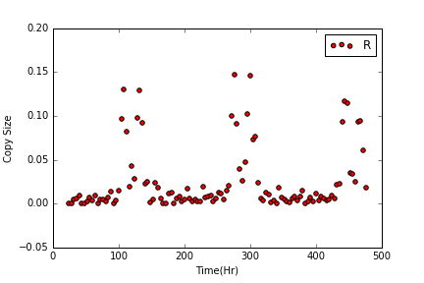
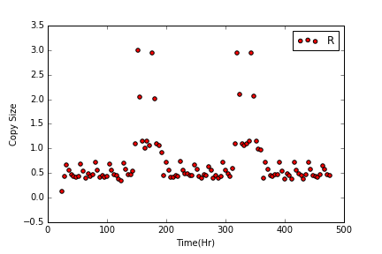

Figure for Workflow-3 days 1 to 20 Figure for Workflow-4 days 1 to 20

The other time plots for the workflows also show similar pattern.

2 b) RANDOM FOREST MODEL:

Random forest models have two parameters, the depth of tree and the number of estimators. These we tuned using 5 fold cross validation function. Following are the plots obtained for tuning these hyper parameters:

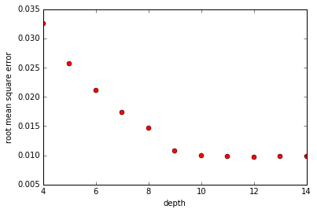

Figure showing MSE vs Depth of tree plot. The peak is obtained at depth =12.

Now, we vary the number of estimators,

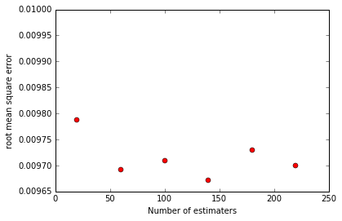

The optimum value for estimators is 140.

So Optimal Hyperparameters: Depth = 12, Number of estimators = 140.
With these parameters, best RMSE = 0.00967.

The RMSE for Random Forest is better than that obtained from linear regression.

The Models obtained from random forest algorithms show similar pattern as we obtained in part 1.

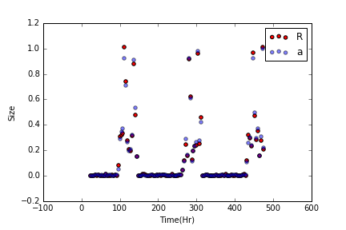

As we can see in the figure, the models almost fit on top of each other. The Red plot are the original values and the blue ones are the predicted values. The residual value plot for the same is given below:

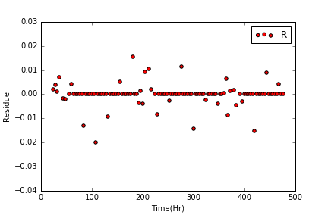

The plot is concentrated around zero showing good matching of the predicted and actual values.

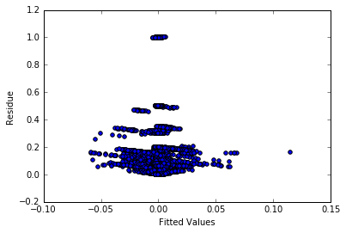

The graph shows residual vs fitted values. We see that since most of the error points are concentrated close to zero(expected as most labels are very close to zero). So labels which might not actualy be zero are predicted as zero.

Housing dataset:

The tuning parameters for the random forest model on housing dataset are obtained as

Plot for tuning depth:

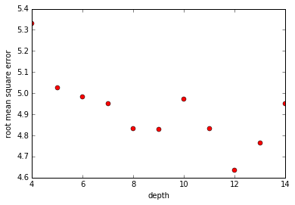

Here we find that minimum rmse is when depth = 12.

Now, we vary the number of estimators,

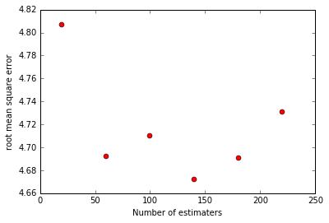

Here the minimum RMSE is when the number of estimators are 140

So, optimal hyper parameters: Depth = 12 and No. of Estimators = 140,
For these parameters RMSE for the random forest algorithm is 4.728.

Plot for residue vs the fitted values for Housing dataset using Random Forest Model.

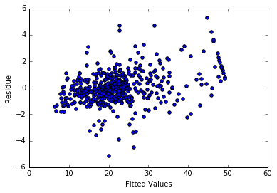

Here, we observe that that the random forest model fits well on the housing dataset. Most residue concentration is around 0. For large label values, the error seems to be more compared to labels which have values around the average 20 ($20,000).

(c) Neural Regression

The Neural Network model we used for regression is composed of one hidden layer. The number of nodes in the hidden layer and the learning rate were found using parameter tuning. Variation of RMSE for these two parameters is shown below.

Plots for Data size model

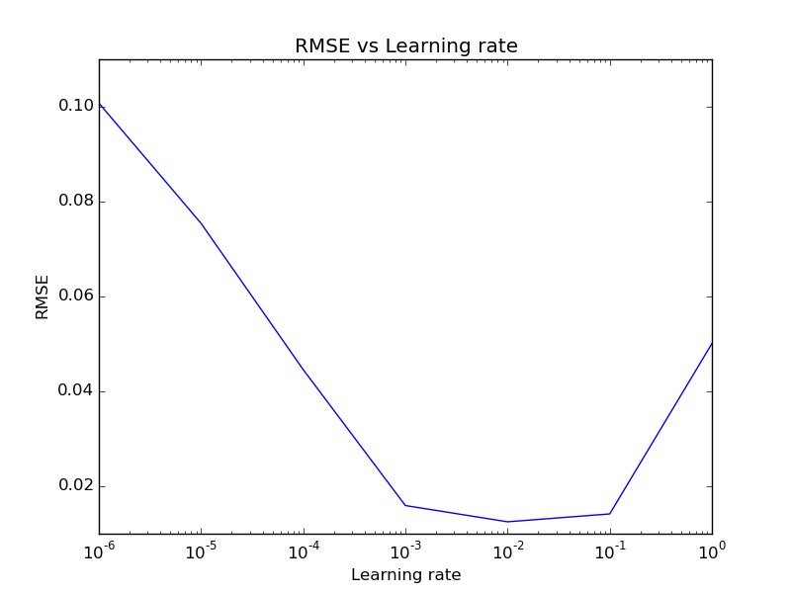
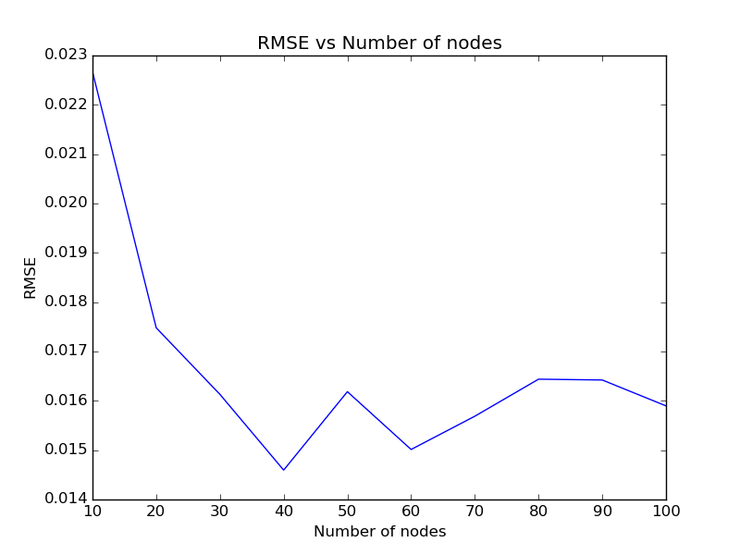

Plots for Data time model

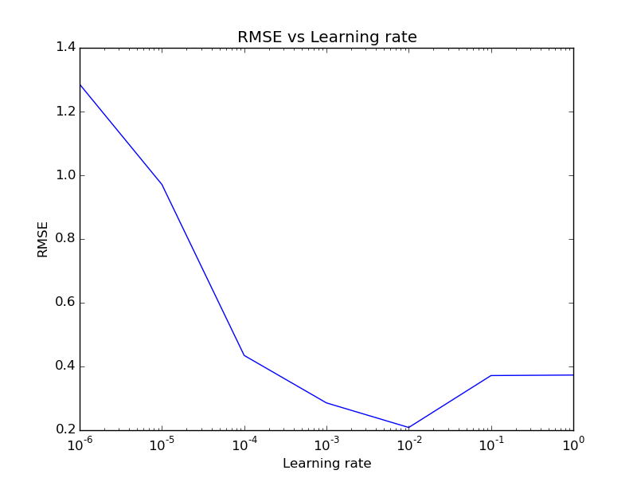
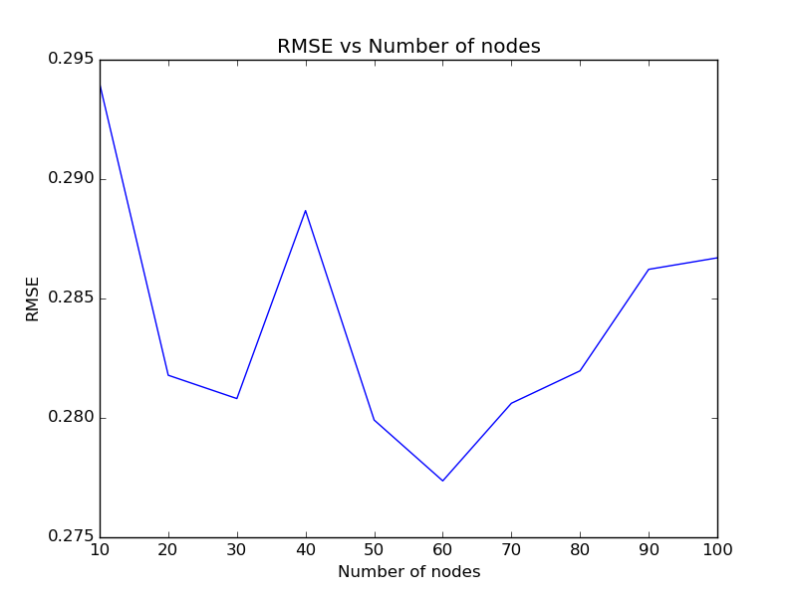

Cross validation RMSE using the tuned parameters:

Data set | RMSE
Data Size | 0.018
Backup time | 0.27

Plots for Backup time

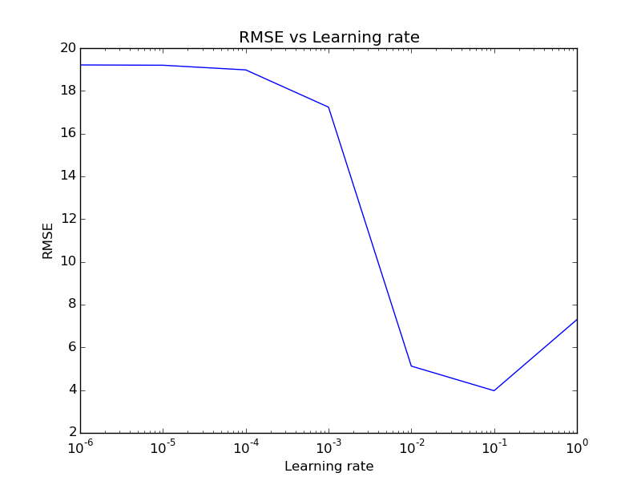
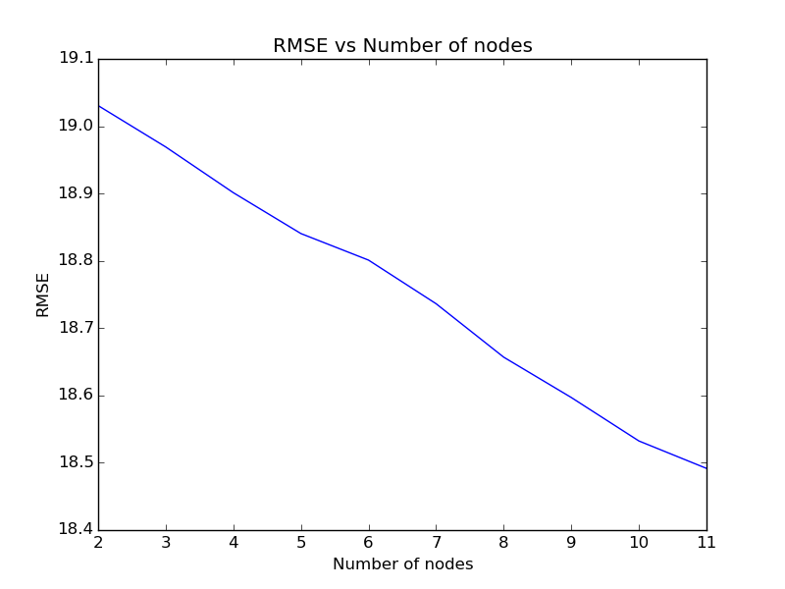

Cross validation RMSE using the tuned parameters:

Data set | RMSE
Housing | 5.99

Summary of the parameters used for Neural network regression:

1. Number of nodes in hidden layer: Tuned using cross validation.
2. Learning rated: Tuned using cross validation
3. Activation function of hidden layer: Tanh
4. Activation function of hidden layer: Linear
5. Optmizer used: Adam.

